Difference between HTTP1 and HTTP2:

HTTP1:

HTTP is a top-level application protocol that exchanges information between a client computer and a local or remote web server. In this process, a client sends a text-based request to a server by calling a method GET. In response, the server sends a resource like an HTML page back to the client.

HTTP2:

HTTP/2 is multiplexed, i.e., it can initiate multiple requests in parallel over a single TCP connection. As a result, web pages containing several elements are delivered over one TCP connection. These capabilities solve the head-of-line blocking problem in HTTP/1.1, in which a packet at the front of the line blocks others from being transmitted.

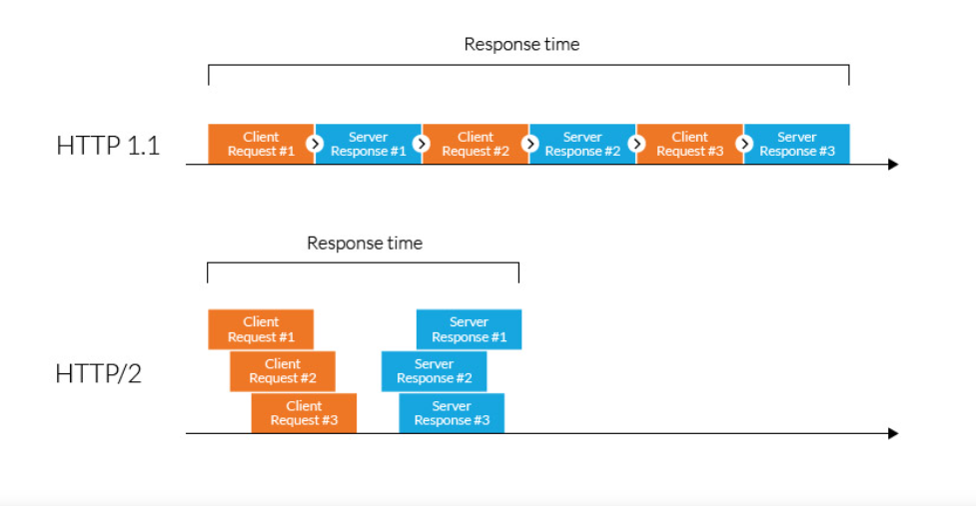

Object and It’s internal representation in Javascript:

Objects, in JavaScript, is it’s most important data-type and forms the building blocks for modern JavaScript. These objects are quite different from JavaScript’s primitive data-types(Number, String, Boolean, null, undefined and symbol) in the sense that while these primitive data-types all store a single value each (depending on their types).

Objects are more complex and each object may contain any combination of these primitive data-types as well a reference data-types. An object, is a reference data type. Variables that are assigned a reference value are given a reference or a pointer to that value. That reference or pointer points to the location in memory where the object is stored. The variables don’t actually store the value.